 | Outline Validation as a Chartered Scientist (CSci) – 20+ years’ Route  Account of Career | 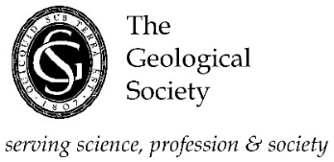

Name of Applicant: …………………………………………………
Instructions for completion of your Career Account
Your Career Account should summarise your geological experience relevant and cross-referenced to the seven Chartership Criteria set out below (see also Regulation R/FP/11 clause 5.5, available on our website)
The Competency Criteria are:
- Application of knowledge and understanding. Applicants meeting this criterion will be able to demonstrate competence in:
- the use of specialist experiential knowledge and broader scientific understanding to optimise the application of existing and emerging science and technology;
- the exercise of sound judgement in the absence of complete information and in complex or unpredictable situations; and
- the critical evaluation of relevant scientific information and concepts to propose solutions to problems
- Personal Responsibility. Applicants meeting this criterion will be able to demonstrate competence in:
- working autonomously and taking responsibility for the work of self and others;
- promoting and implementing robust policies and protocols relating to health, safety and security;
- promoting and ensuring compliance with all relevant regulatory requirements and quality standards; and
- overseeing the implementation of solutions with due regard to the wider environment and broader context.
- Interpersonal skills. Applicants meeting this criterion will be able to demonstrate competence in:
- the ability to communicate effectively with specialist and non- specialist audiences;
- effective leadership through the ability to guide, influence, inspire and empathise with others; and
- the ability to mediate, develop and maintain positive working relationships
- Professional Practice. Applicants meeting this criterion will be able to demonstrate competence in the ability:
- to scope, plan and manage multifaceted projects;
- to achieve desired outcomes with the effective management of resources and risks; and
- to take responsibility for continuous performance improvement at both a personal level and in a wider organisational context.
- Professionalism. Applicants meeting this criterion will be able to demonstrate competence in the ability:
- to understand and comply with relevant codes of conduct; and
- to show a commitment to professional development through continuing advancement of own knowledge, understanding and competence.
Leave the remainder of this page blank and commence your Career Account
on the next page

Career Account
Continue on additional sheet(s) if necessary and sign at the end of your Account

